**Walk 7 Edvin and Edwyn**

Last walked in March 2017

**Description.** A 8 km (5 miles). Three remote churches secreted amongst the rolling countryside to the north of Bromyard Downs are the targets of this walk. Ranging from early Norman to Victorian in age, each has a story to tell, a heady mix of heroism, piety and larceny. The route offers far-reaching views across this corner of Herefordshire, rich farmland at the headwaters of the River Frome, an unsung waterway that flows all the way from this northern corner of the county to the River Wye near Hereford.

**Start.** Edvin Loach car park. Explorer Map 202 Grid 663585.

**Direction from Whitecross roundabout** (Turn milometer to zero). Take the A4110 Canon Pyon (Three Elms road) for 1 mile and TR at the traffic lights onto the A4103 Worcester (Roman road). Go thru two roundabouts and at 3.7 miles TL onto the A465 to Bromyard. Near Bromyard, at 14.6 miles, TL onto the B4214 to Tenbury. At the T-junction, (15 miles) go straight across and continue onto Tenbury. At 15.5 miles TL to Tenbury. At 19 miles TR and continue along a narrow road to Edvin Loach 1. At 19.8 miles TR to Edvin Loach. At 20.3 miles TR to Edvin Loach church and at 20.4 miles you park at the church.

***Edvin Loach has two churches; the small Victorian replacement and the ancient original. This latter was built shortly after the Norman Conquest in a style that recalled the church architecture of the Saxons and is thus often known as the Saxon Church. Of particular note is the herringbone pattern of many of the earliest walls still standing. The replacement St Mary’s Church was built by a local businessman, William Barneby.***

**1.** **Edvin Loach.** Walk back along the rough approach road and at the T-junction TR - ***Off to your R, the Malverns draw the eye south beyond the heights of the nearby Bromyard Downs; to the north is Titterstone Clee Hill, capped by a radar dome.*** Walk down the lane for about ½ km to reach THE STEEPLES, a farm on the L that supplies quality milk. TR and walk up the lane opposite the postbox. After about 400m the lane bends R, ignore the lane to the L, and walk on round for a few paces to TL thru a gateway into **F1**. Stick to the L edge of the field, passing R of an isolated cottage. Continue in the same direction across a short stretch of open farmland to go thru a small wooden gate into a wood. Drop straight down to go over a wooden footbridge into **F2**. Go half L to go over a stile/metal gate that’s near a house(L), and walk on up the tarred driveway to reach the road.

**2. T-junction.** At the T-junction TR, follow this quiet road for about ¾ km thru to the Brickhouse Farm. When the road bends L, look R for a fingerpost that’s at the end of a small stone structured barn, TR and go thru a gate into **F3**. Walk across this field and between ponds, to go thru a gate into **F4**. Keep to the R field edge (a brook is on your R), and go thru a metal gate in the corner, into **F5**. TL and walk up the L edge of the field, (heading for the church spire), to go thru a metal kissing gate into **F6**. Continue along and around the L field edge (this field may be split in two). At the field end you TL thru a small metal gate, then TR to go thru a metal gate onto a narrow road. TL and walk on to reach St Michael’s Edvin Ralph church. ***St Michael’s Church dates from the late 12th century. Inside is one of the finest collections of effigy tombs in the county, including knights and rare ‘Pardon Monuments’ – offering a prayer to this was said to grant the supplicant up to 60 days’ pardon of sins. (Use the R hand light switch by the door.) In the trees to the west of the churchyard is a motte-and-bailey castle, all that remains of a village that succumbed to the Black Death plague in 1349AD.***

**3. St Michael’s Church.** Continue along the road and turn the corner at Townsend Farm (prominently displayed), and about 100m further on you reach two fingerposts on your R. Choose the first of these, climb the stile and stick to the L edge of four fields (**F7,** **F8,** **F9,** **F10**) keeping above a brook that’s on your L. At the ultimate L corner when you reach a wider brook/stream that’s in front of you, TL and go thru a way marked metal gate, across the culvert into **F11**. Walk beside the brook/stream that’s on your R. Just before the next corner TR, then TL before the bridge and go thru a metal gate and along a wide concessionary bridle path. Continue along this bridle path, keeping the brook/stream on your R, for just over ½ km to reach a bridgeway on your R that crosses the brook/stream.

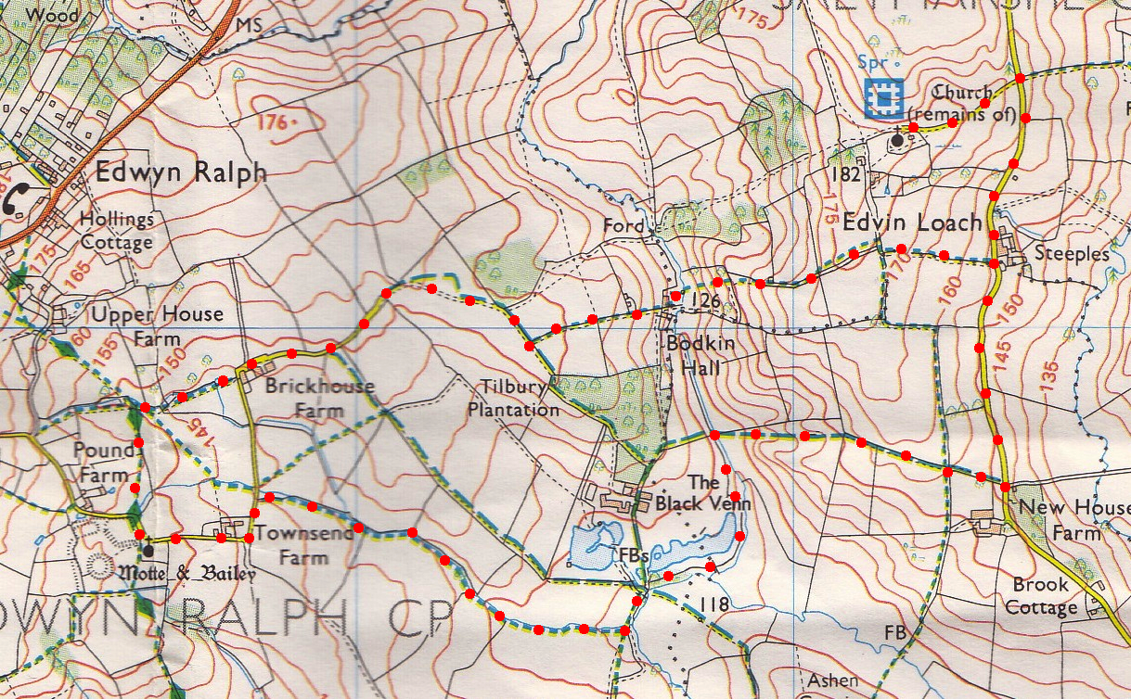**4. Bridge.** TR here, cross the bridge and thru the waymarked metal gate into **F12**. Climb the field to pass L of the ruined cottage. Go thru a metal gate into **F13** and join a rocky farmers track that goes on thru a hedge gap into **F14**. Continue on to go thru a metal gate and walk along the R hand edge of **F15** to go thru another gate and onto a minor road near New House Farm. TL to walk back to the signposted church access road, passing THE STEEPLES, which is on your R. **There were two young noblemen one from each parish who fought a duel for the hand of a certain lady, this lady hearing of the fight rushed between the duist but died when her body was pieced by both swords. The two men, grief maddened fought on until they both died. The three bodies are said to be buried in Edvin Ralph Church.**

**2**

**1**

**4**

**3**